Design an HTML page with the relevant CSS (inline /internal/external styles)for the following use case:
d. Customer feedback page.

SOURCE CODE
<!DOCTYPE html>
<html>
<head>
<title>Customer Feedback</title>

<style>
body {
background-color: #713b50;
font-family: Arial, sans-serif;
color: #59464a;
margin: 0;
padding: 30px;
}

h1 {
text-align: center;
color: white;
font-family: "Times New Roman", Times, serif;
}

.intro {
background-color: #f3e5d8;
padding: 15px;
text-align: center;
margin-bottom: 25px;
border: 5px solid #a86f7c;
line-height: 1.6;
font-size: 20px;
}

form {
background-color: #fffaf5;
padding: 25px;
border: 1px solid #e2c9c0;
}

label {
font-weight: bold;
}

input,
textarea,
select {
width: 100%;
padding: 10px;
margin-top: 8px;
margin-bottom: 18px;
border: 1px solid #e2c9c0;
box-sizing: border-box;
font-family: Arial, sans-serif;
}

textarea {
height: 100px;
}

.rating {
margin-bottom: 18px;
}

.rating input {
width: auto;
margin-right: 5px;
}

button {
background-color: #a86f7c;
color: white;
padding: 12px 28px;
border: none;
border-radius: 25px;
cursor: pointer;
font-size: 15px;
}

button:hover {
background-color: #542a3b;
}
</style>
</head>

<body>
<h1>WE VALUE YOUR FEEDBACK</h1>

<div class="intro">
<p>
Your feedback helps us improve and serve you better. Please take a
moment to share your experience with us.
</p>
</div>

<form>
<label>Full Name:</label>
<input type="text" placeholder="Enter your name" />

<label>Email Address:</label>
<input type="email" placeholder="Enter your email" />

<label>How was your overall experience?</label>
<select>
<option>Select your experience</option>
<option>Excellent</option>
<option>Good</option>
<option>Average</option>
<option>Poor</option>
</select>

<label>Rate our service:</label>

<div class="rating">
<input type="radio" name="rating" /> Poor
<input type="radio" name="rating" /> Fair
<input type="radio" name="rating" /> Good
<input type="radio" name="rating" /> Very Good
<input type="radio" name="rating" /> Excellent
</div>

<label>What did you like about our service?</label>
<textarea placeholder="Share your thoughts..."></textarea>

<label>What can we improve?</label>
<textarea placeholder="Tell us how we can do better..."></textarea>

<label>Would you recommend us to others?</label>
<div class="rating">
<input type="radio" name="recommend" /> Yes
<input type="radio" name="recommend" /> No
</div>

<button type="submit">Submit Feedback</button>
</form>
</body>
</html>
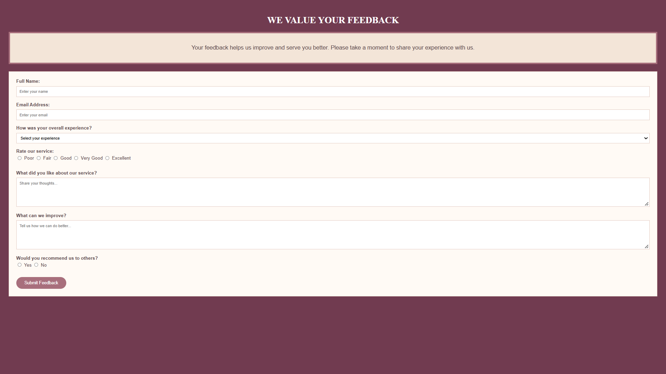
OUTPUT

